CIRCUITPY Midi Expression Controller

General Operation
The device is plug-and-play, it should work out of the box on any system. It also comes equipped with MIDI-din trs out, to use direct with hardware.

MIDI trs connectors
The circuitpy midi controller is equipped with a Type-a TRS connector, which is used by korg products.
For an better understanding of MIDI trs connectors, check out this site: https://minimidi.world/.
The following list shows how the midi pins are connected in brief:
Tip: data (pin 5)
Ring: Vcc (pin 4)
Sleeve: ground (pin 2)

Changing MIDI channel and MIDI cc
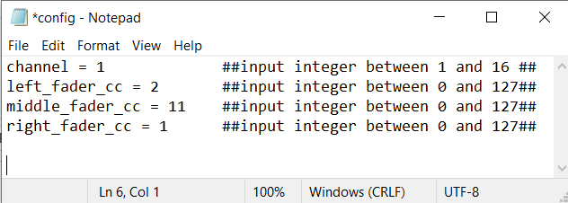
Fairly self explanatory – open the config file in a basic text editor, and input your preferred values. Save file, and reset the controller (unplug, and plug back in)

Raspberry Pico set-up guide

- Flash Raspberry pico with circuitpython. Follow this guide here:
https://learn.adafruit.com/getting-started-with-raspberry-pi-pico-circuitpython/circuitpython
- Download adafruit_midi library here: https://github.com/adafruit/Adafruit_CircuitPython_MIDI
- Download adafruit_hid library here: https://github.com/adafruit/Adafruit_CircuitPython_HID/
- Place adafruit_hid and adafruit_midi folders into /lib folder on pico drive
- Download the code here: https://github.com/jamesdcheetham/midi_expression_controller
- copy code.py and config.py into root folder

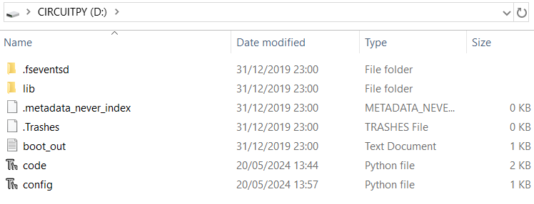
this is what the root folder will look like
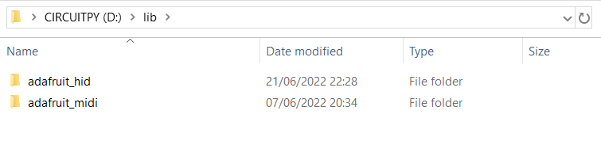

this is what the lib folder will look like

